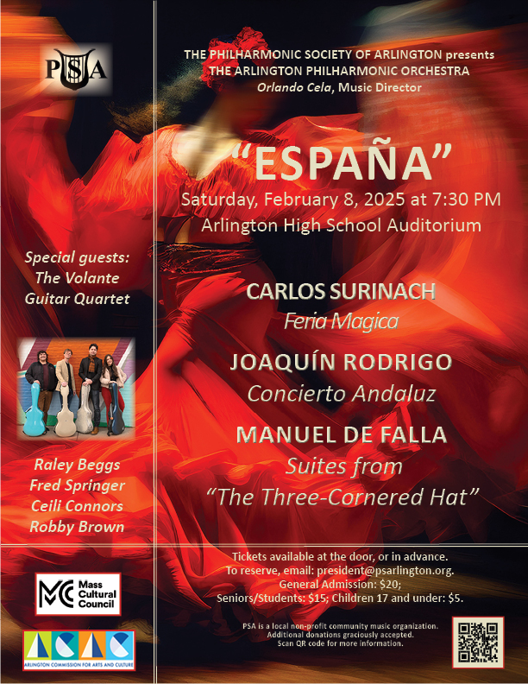♫ Welcome Back! ♫

Thank you to Arlington High School for hosting the Arlington Philharmonic Orchestra

Special thanks to Hal Knowlton and Jing-Huey Wei at Arlington High School

This concert season's programming is funded in part by a grant from the Arlington Commission for Arts and Culture, a local agency which is supported by the Mass Cultural Council, a state agency.



Saturday, February 8, 2025

The Philharmonic Society of Arlington presenting:

A MID-WINTER CONCERT

“España”

with the

ARLINGTON PHILHARMONIC ORCHESTRA,

Orlando Cela, Music Director and Conducting

Program

Feria Mágica [Magic Fair], Overture Carlos Surinach (1915– 1997)

Concierto Andaluz Joaquín Rodrigo (1901 – 1999)

Featuring Volante Guitar Quartet: Raley Beggs, Fred Springer, Ceili Connors, & Robby Brown

Movements:
- Tiempo de Bolero

- Adagio

- Allegretto

Intermission

Suites from “The Three-Cornered Hat” Manuel de Falla (1876 – 1946)

Featuring mezzo-soprano soloist: Felicia Gavilanes

Introduction

Part I

- Introducción (Introduction)

- La tarde (The Afternoon)

- Danza de la molinera (Dance of the Miller's Wife) (Fandango) — El corregidor — La molinera

- Las uvas (The Grapes)

Part II

- La noche (At Night): Danza de los vecinos (Dance of the Neighbors) (Seguidillas)

- Danza del molinero (Dance of the Miller) (Farruca) — Escena (Allegretto) — Las coplas del cuco (The Cuckoo Couplets) (Nocturno)

- Danza del corregidor (Dance of the Magistrate) (Minué) — Allegro

8. Danza final (Final Dance) (Jota)

Program Notes

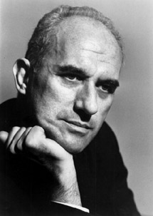
Carlos Suriñach (1915 – 1997) was born in Barcelona, Spain on March 6 of 1915. His Austrian-Polish mother was a house pianist, introducing him to music at a young age. He began playing the piano between ages 5–6 and started the formal study of music at around age 10. His father was involved in business as a stockbroker. In late 1950, Carlos Suriñach emigrated to the United States in hopes of becoming a successful published composer. World War II had just recently ended and European publishers were frantically republishing previous music of the greats: Beethoven, Mendelssohn, Chopin, etc. Full of ambition, he first stopped in New York to conduct an orchestra. In May 1951, a concert featuring the New York's most elite artists was held at the Museum of Modern Art. In 1956, Surinach composed Feria Magica [Magic Fair], Overture. Featuring lively dance rhythms and a rich orchestration combine to make this flamenco inspired symphony.

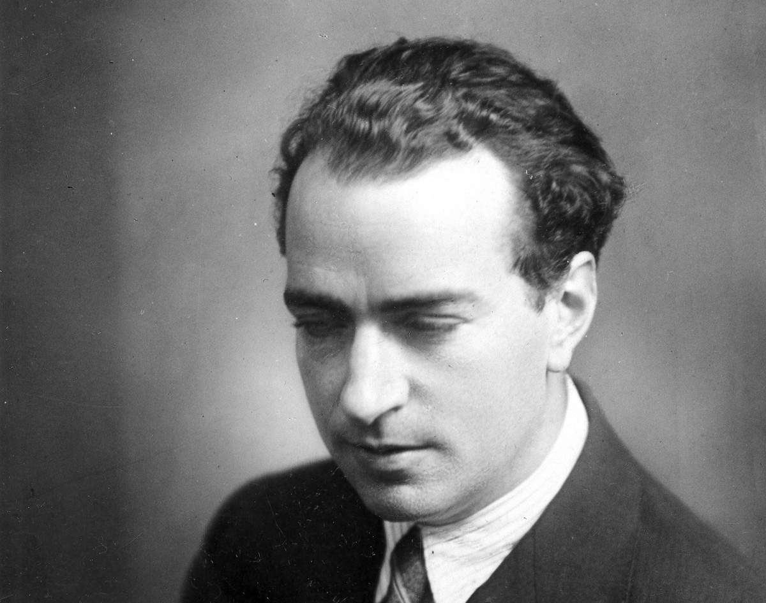
Joaquín Rodrigo (1901 – 1999) was born in Sagunto, Province of Valencia, Spain. At the age of three, he lost his sight completely after contracting diphtheria. At the age of eight he began to study solfège, piano, and violin and from the age of 16 he studied harmony and composition. He wrote his compositions in Braille and they were transcribed for publication. During much success in the 1930’s, Rodrigo was commissioned by the San Antonio Symphony Orchestra to write a piece for a renowned guitar quartet- Los Romeros and debuted ‘Concierto Andaluz’, on November 18th, 1967. Consisting of 3 movements performed by four guitars depicting inspiration brought by the music and landscape of the Andalusia region of Spain and the abilities of the famous Los Romeros quartet. Throughout the piece, characteristics of flamenco forms and debut performances praised by Rodrigo for making the difficult guitar techniques written to seem simple by the performers.

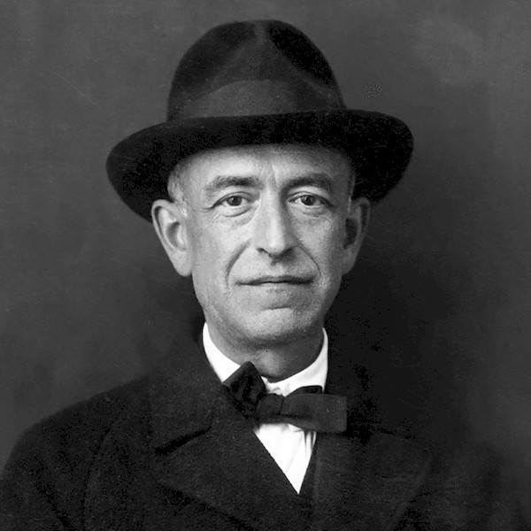
Manuel de Falla (1876 - 1946) was the most distinguished Spanish composer of the early 20th century. In his music, he achieved a fusion of poetry, asceticism, and ardour that represents the spirit of Spain at its purest. The Three-Cornered Hat (Spanish: El sombrero de tres picos or Le tricorne) is a ballet choreographed by Léonide Massine to music by Manuel de Falla. Commissioned by Sergei Diaghilev, the ballet premiered in 1919. In addition to its Spanish setting, this ballet also employs the techniques of Spanish dance (adapted and somewhat simplified) instead of classical ballet. The story of a magistrate infatuated with a miller's faithful wife, whom he attempts to seduce, derives from the novella of the same name by Pedro Antonio de Alarcón. Falla did not prepare "suites" from this work although excerpts are performed under this term. The music is in eight main sections, split across an introduction and two parts, or acts, with some bridging scenes.

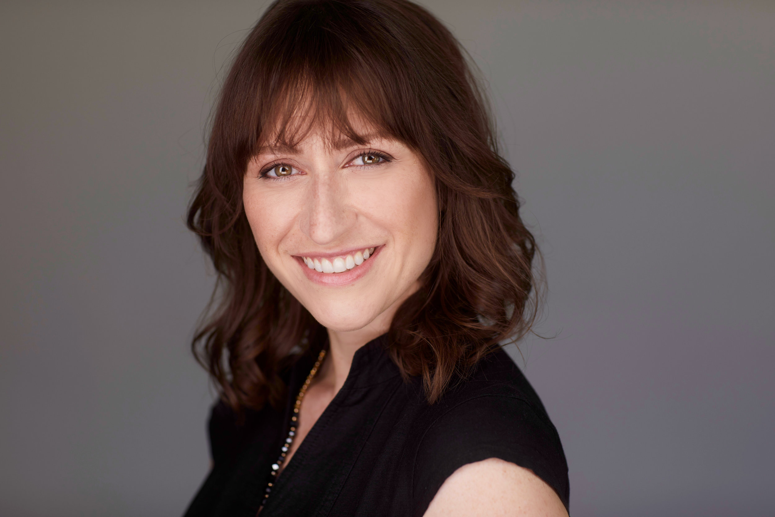
Felicia Gavilanes, Mezzo Soprano, Italian American mezzo-soprano Felicia Gavilanes is gaining a reputation as an exciting and versatile singing actress. An Emerging Artist Alumna with Boston Lyric Opera, Felicia is a frequent performer in both mainstage and concert roles in Boston and throughout New England. Felicia recently made her Jordan Hall debut as Ino in Boston Modern Orchestra Project and Odyssey Opera’s East Coast Premiere of John Corigliano’s The Lord of Cries, starring Anthony Roth Costanzo. Recent company and role debuts include Salt Marsh Opera (Mercedes in Carmen), Teatro Lírico Nacional de Cuba (Dido in Dido and Aeneas), Odyssey Opera (Léœna in La Belle Hélène), Winter Opera St. Louis (Zulma in L’Italiana in Algeri), and Gulfshore Opera (Maria in Lauda per la natività). A dual citizen of the U.S. and Italy, Felicia completed her Bachelor of Arts in Italian Literature and Music from Dartmouth College. She received her Master of Music with Honors from the New England Conservatory and her Doctorate from Florida State University. Her first full-length album, La Sera, a celebration of art song from Italy’s golden salon age, was released in 2024. https://feliciagavilanes.com/

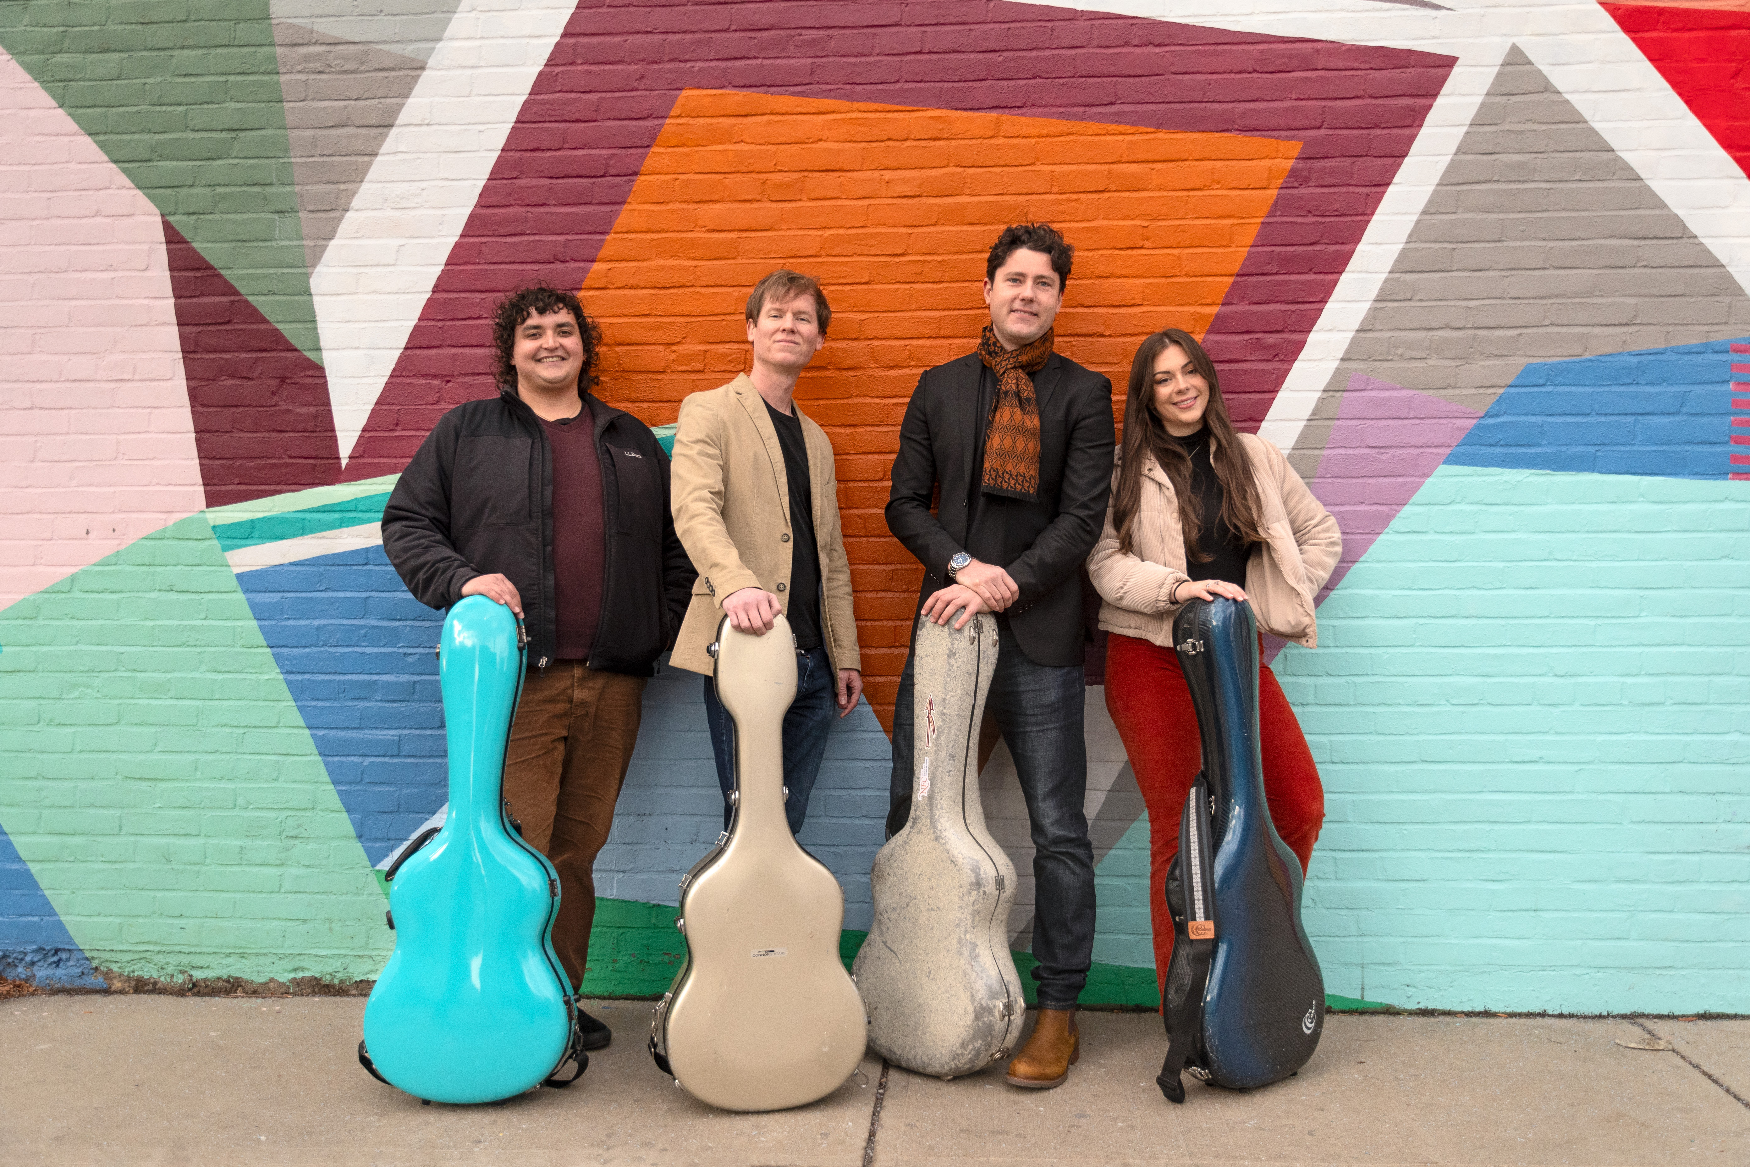
Volante Guitar Quartet
Volante Guitar Quartet is a dynamic ensemble consisting of Dr. Raley Beggs, Fred Springer, Robby Brown, and Ceili Connors. Based in Boston, the members perform regularly as soloists and chamber musicians and hold a variety of teaching positions at local music schools. Representing a new generation of classical guitarists, the group carries on traditions passed on to them by their various mentors, including the premier American guitarists and pedagogues Eliot Fisk, Adam Holzman, and Bruce Holzman. Volante Guitar Quartet was established in 2024 to present exciting and engaging concerts in a variety of settings. Their performance with the Arlington Philharmonic Orchestra marks their debut as a quartet.

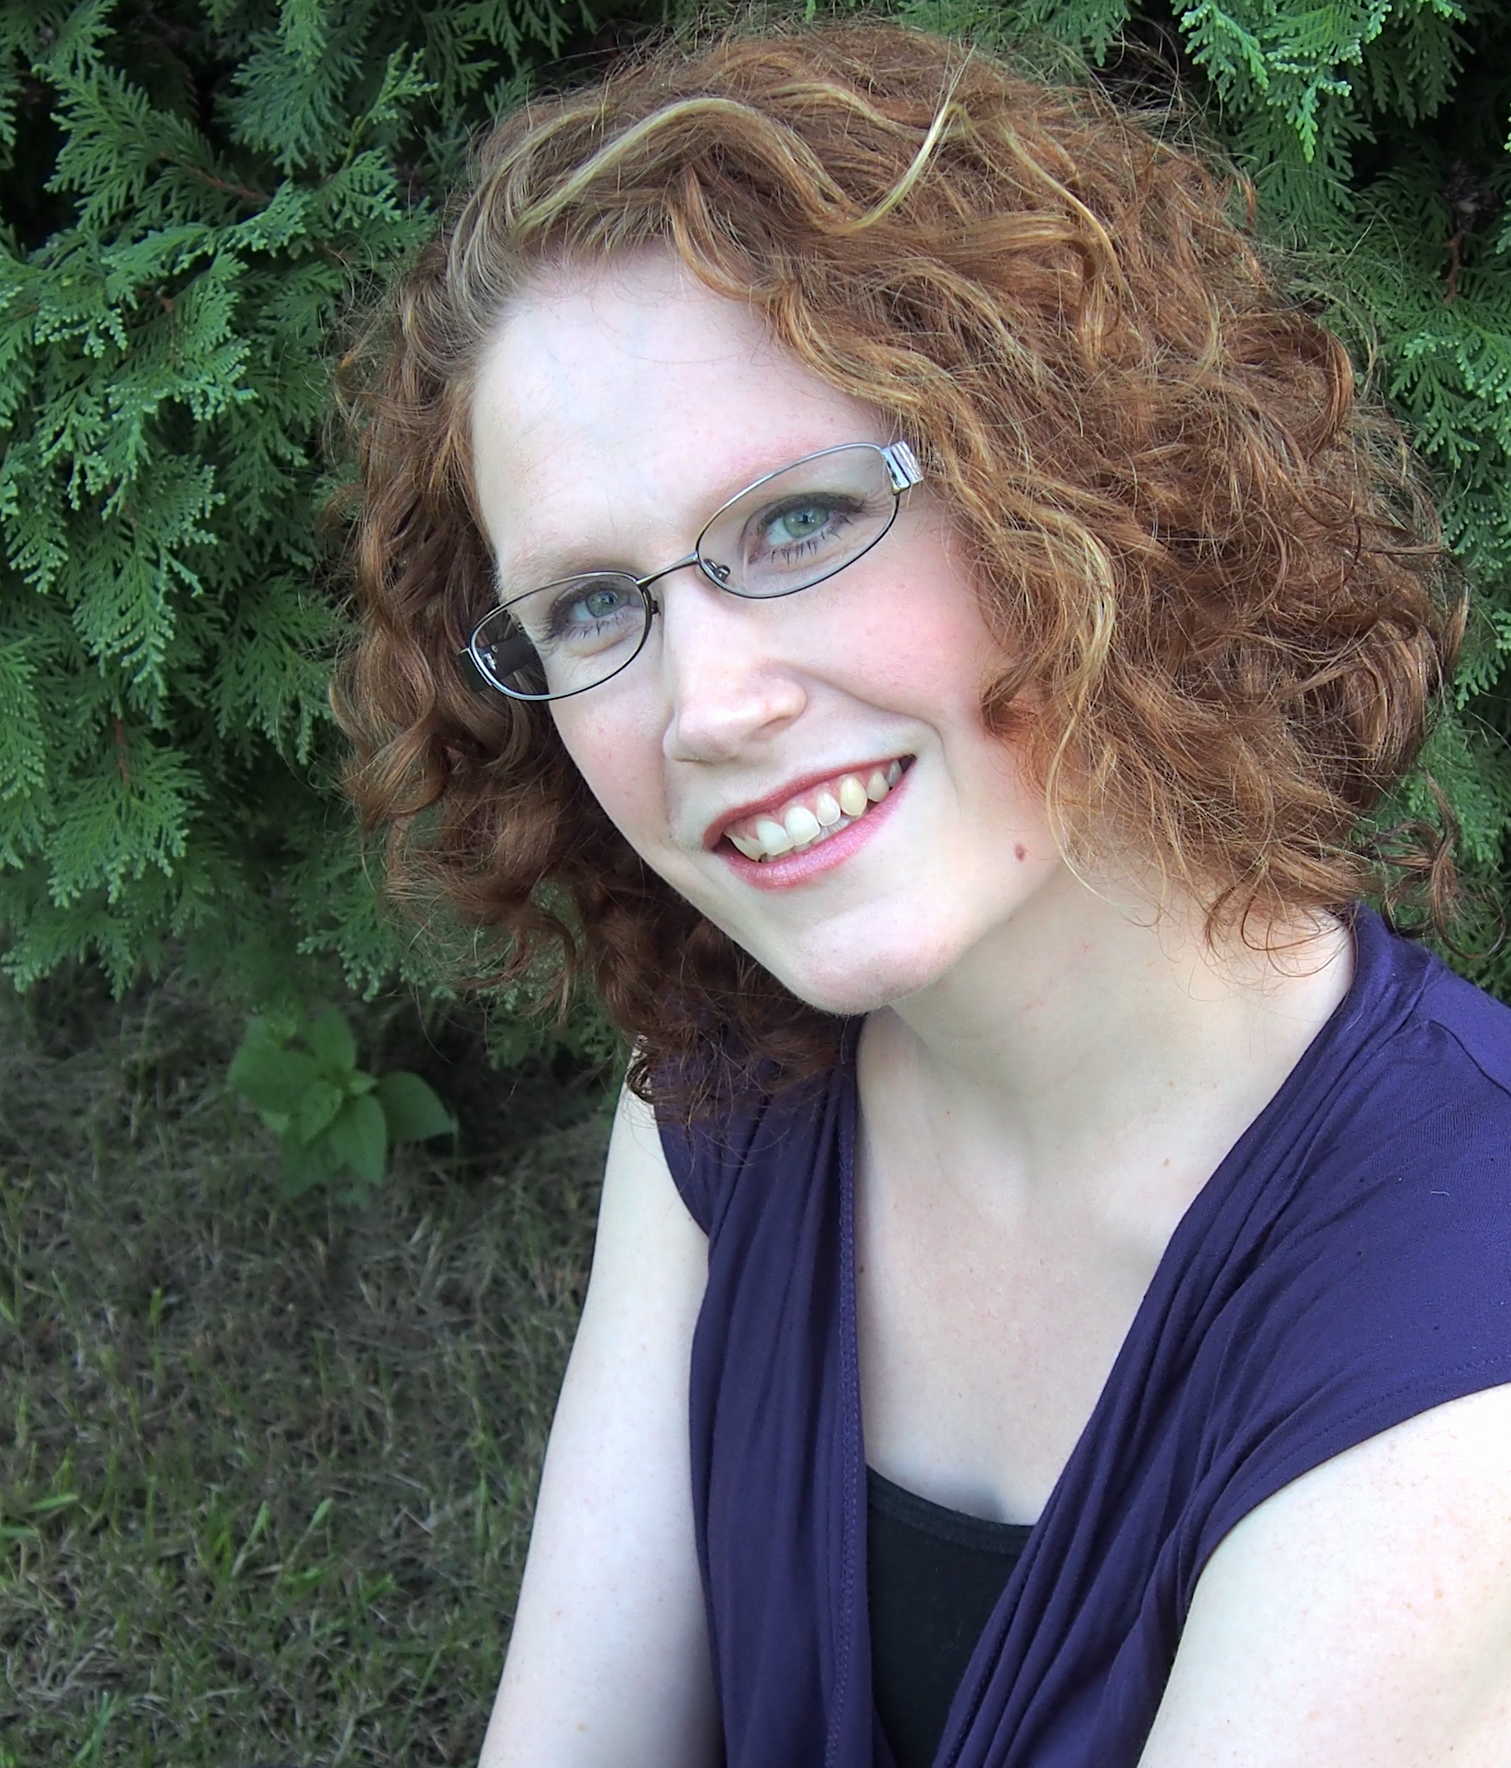
Nicole Parks, APO Concertmaster Violinist, Nicole Parks, uses her career as a performer and educator to bring new music and inclusive programming to a wide range of audiences. She is a co-founder of the Semiosis Quartet, a string quartet that focuses on the music of the 20th and 21st centuries. Previously, she created and conducted The Lirica Chamber Ensemble to play rarely heard and new works for chamber orchestra.
In August 2019, Semiosis Quartet appeared at Tanglewood with Bill Barclay and Concert Theatre Works in a production of The Black Mozart, featuring the music of the Chevalier de Saint-Georges. During the 2018-19 season, they also collaborated in performances with Ogni Suono, and The Boston New Music Initiatives; made their Southwest debut at the Oh My Ears! Festival in Phoenix; and appeared at the International Alliance for Women in Music Conference. Deeply committed to music education, Semiosis is on the faculty at The Boston Conservatory at Berklee’s High School Composition

Intensive, and has worked closely with student composers, musicians, and faculty at Tufts University, MIT, and Bowling Green State University. She currently holds concertmaster positions with the Philharmonic Society of Arlington and appears regularly with ensembles such as the Boston Modern Orchestra Project, Odyssey Opera, Equilibrium, Guerilla Opera, New Bedford Symphony Orchestra, Portland Symphony Orchestra, Monadnock Music, and the Rhode Island Philharmonic. https://www.nicoleparksviolin.com/

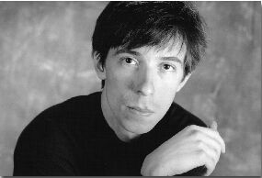
Orlando Cela, APO Music Director “In Orlando Cela’s able hands and imagination, a flute becomes a world orchestra,” says the Oregon ArtsWatch about Orlando’s lively performances that open new worlds of experience. Known for his compelling renditions, using imaginative programming, Orlando has premiered over 200 works, both as a flutist and as a conductor, to rave reviews from the media from the Boston Globe to the Oregon ArtsWatch. In concert, Mr. Cela regularly offers short lively introductions to selected works, providing audiences with entry points into unfamiliar works, so that listeners can easily connect the music with other life experience. As a flutist, Mr. Cela has performed at the National Portrait Gallery of the Smithsonian (Washington DC), the Isabella Stewart Gardner Museum (Boston), and at the Center for New Music and Technologies at UC Berkeley. His credits abroad include concerts at the Zentrum Danziger (Berlin), the Espace des Femmes (Paris), and at the Musikverein (Vienna). As a collaborative artist, Mr. Cela has concertized with flutist Paula Robison, tabla player Samir Chatterjee, harpsichordist John Gibbons, and with shen (mouth organ) virtuoso Hu Jianbing. He recently became a finalist in the American Prize in the professional instrumentalist division. He recently released his third solo CD, “Shadow Etchings” with rave reviews from Grammophone, Naxos Music, and Avant Music News.

As a conductor, he serves as the Music Director of the Lowell Chamber Orchestra, which he also founded, and the Arlington Philharmonic Orchestra. For nine years, he was the music director of the North Carolina Governor’s School; he has also guest conducted the Manchester Symphony Orchestra, the London Classical Soloists, the Marquette Symphony Orchestra, Worcester Chamber Music Society, Dinosaur Annex, Sound Icon, and others. He created the Ningbo Symphony Orchestra during his year as visiting professor at Ningbo University, in China. Orlando has received the American Prize for conducting youth and community orchestras, the Vytautas Marijosius Prize for orchestral programming, and the Ernst Bacon Memorial Award for excellence in the performance of American music. His interpretation of Beethoven’s Symphonies 7 and 8 with the London Classical Soloists earned him a second prize in their competition. Thanks to his charitable work with the Lowell Chamber Orchestra, in 2024 he was selected by AmplifyLatinx as one of Massachusetts’ 100 most influential Latinos in Massachusetts, and he also received a 2024 Performance Recognition Award from the Commonwealth of Massachusetts.

He currently is assistant professor at Berklee College of Music, where he teaches conducting, and full professor at Middlesex Community College, and coordinator of the MCC Music Outreach Program. Orlando has two masters degrees from the New England Conservatory of Music, where he studied flute performance and conducting with Paula Robison and Tamara Brooks, respectively. He is also a 2024 fellow in the Boston’s Arts and Business Council Creative Entrepreneur Fellowship. www.orlandocela.com

Orchestra Personnel
Violin I  Nicole Parks*  Eiko Asazuma  Hana Asazuma-Cheng  Carolyn Boudreau  Arthur Comengo  Steven Connors  Branwen Hall  Kathryn Hathaway  Larisa Miller  Sandhya Ramakrishnan  Brandy E. Wyant  Violin II  Lynn Burns  Jiayang Chien  L. Ann Chepjian  Franca Duffy  Deni Kea  Larry Kyrala  Jill Pelavin  Carolyn Savich  Sophia Sid  Christine Tessier  Violas  Elizabeth Buschert  Catharine Crawford  Maria Gesiorek  Julianna Keyes  Sara Vail | Cellos  Mira Dandridge  Chris Jensen  Peg McGirr  Joyce Moss  Jeffrey O’Neil  Sandy Reismann  Linda Rossman  Jessica B. Smith  Lynn Stycznski  Double Basses  Norton Allen  Robert Olson  Flutes  Diane Gardner  Julie Goldberg  Virginia Hecker  Piccolo  Diane Gardner  Julie Goldberg  Oboe  Karen Brouady  Haig Iskenderian  Nancy Knight  English Horn  Haig Iskenderian  Clarinets  Stan Gill  Jennifer Lauer  Bassoons  Shant Arakelian  Adam Dixon | Horns  John Hecker  Laura Mesite  Robert Pyle  John Rhoads  Kristie Welsh  Trumpets  David Douglas  Ali Lauer  Jackie Farrell  Karen Sudbey  Trombones  Francois Herlant  Lisa Mula  Dave Schwartz  Tuba  Tim Shepard  Tympani  Shane O’Donohoe  Percussion  Christopher Hazel  Frank Kumiega  Emma Thurston  Hannah Vanstone  Piano  Yukiko Shimazaki  Harp  Emily Halpern-Louis  *Concertmaster

Mark your calendars for more music with The Philharmonic Society of Arlington!
For more programming and information visit our website at www.psarlington.org

The Philharmonic Society of Arlington, Inc. is a 501(c)3 non-profit community organization incorporating The Arlington Philharmonic Orchestra, The Arlington-Belmont Chorale, and The Arlington-Belmont Chamber Chorus.
♪ Thank you for attending! ♪

